**BÁO CÁO THỰC HÀNH LAB 2 LẬP TRÌNH HƯỚNG ĐỐI TƯỢNG**

# Use case diagram:

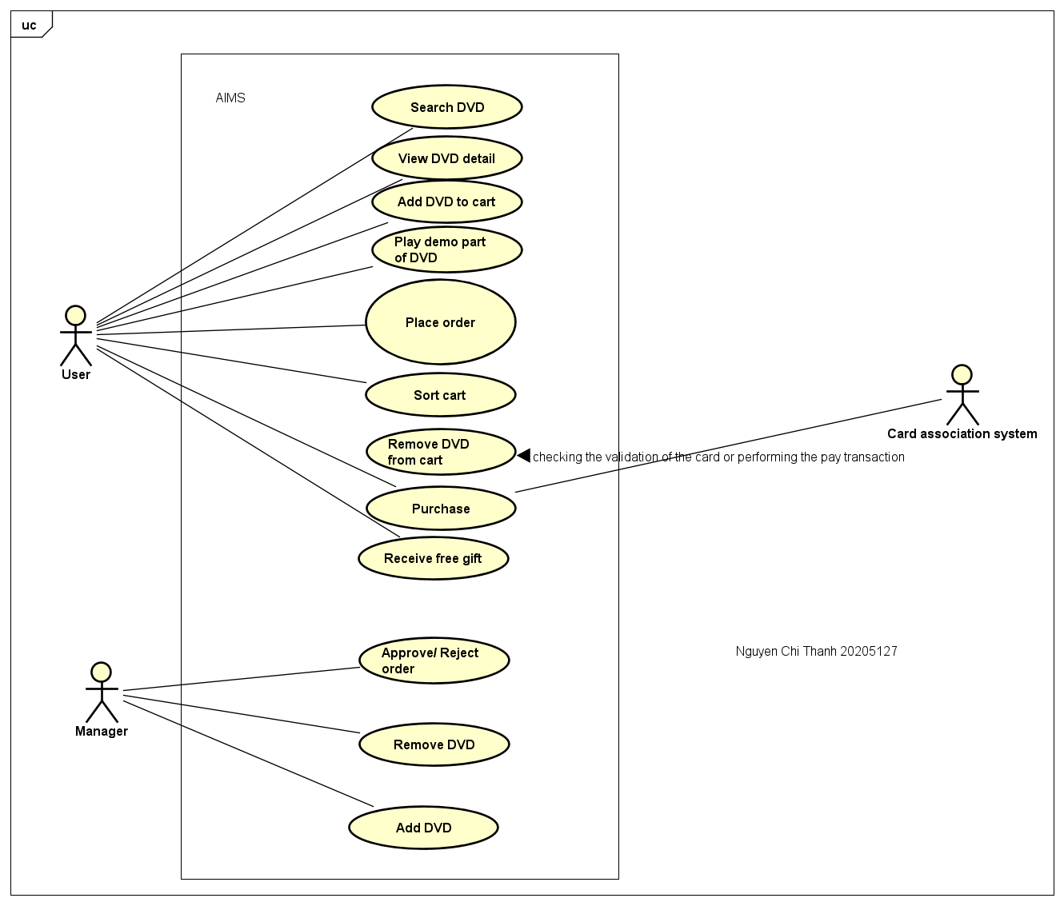

# UML Class Diagram for use cases related to cart management:

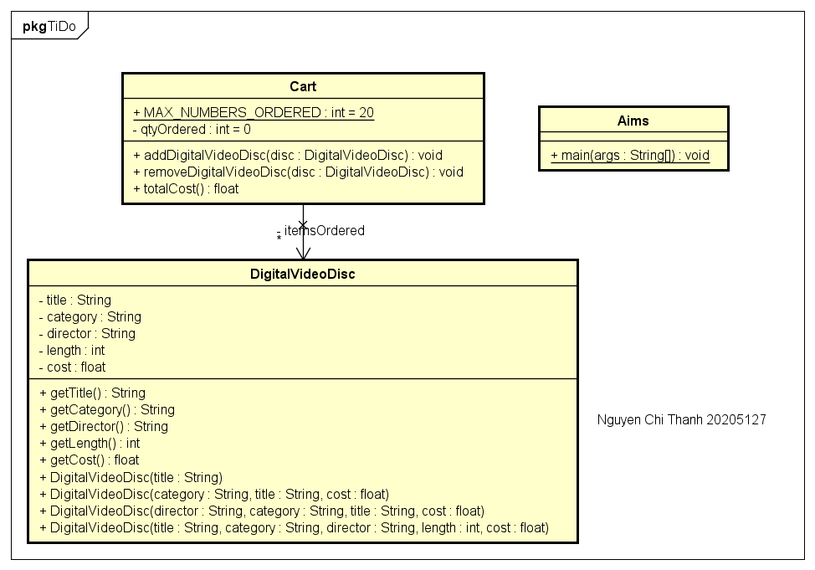

# Create the DigitalVideoDisc class and its attributes:

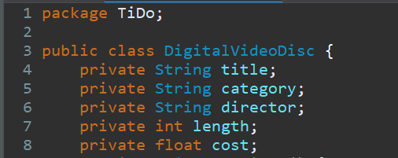

# Create accessors and mutators for the class DigitalVideoDisc:

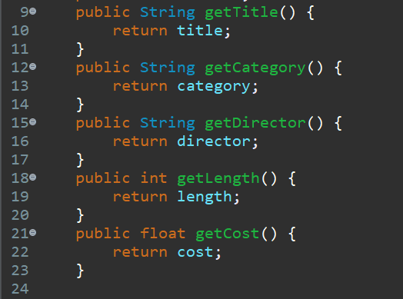

# Create Constructor method:

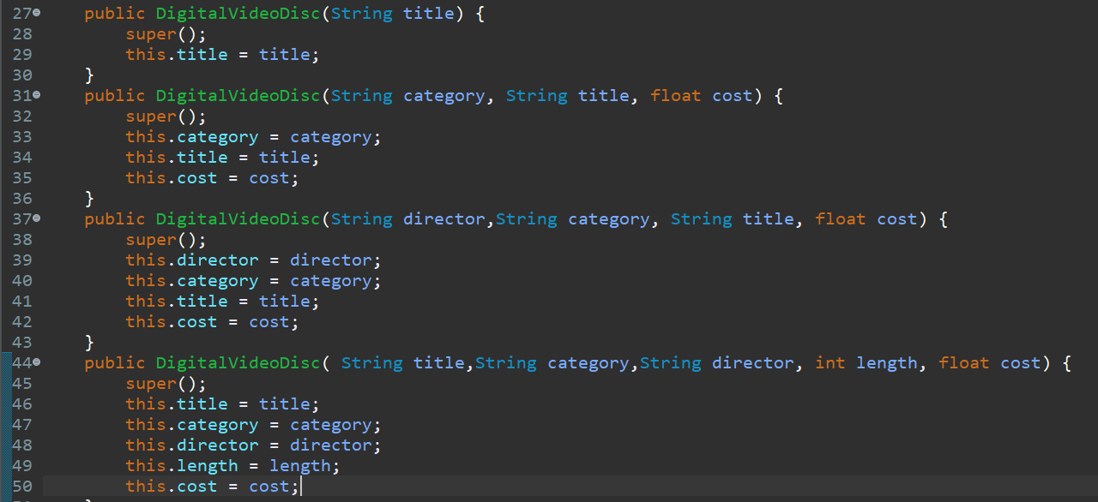

# Create the Cart class to work with DigitalVideoDisc:

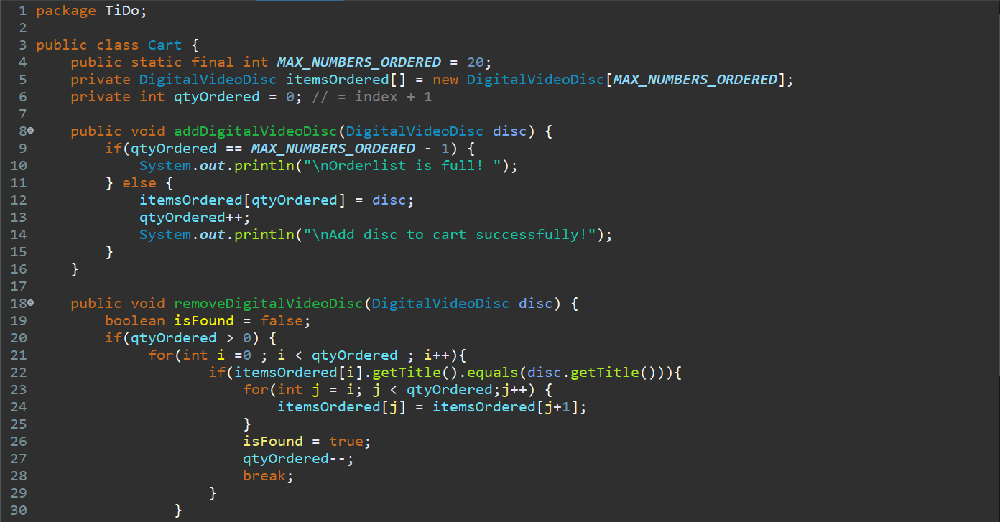 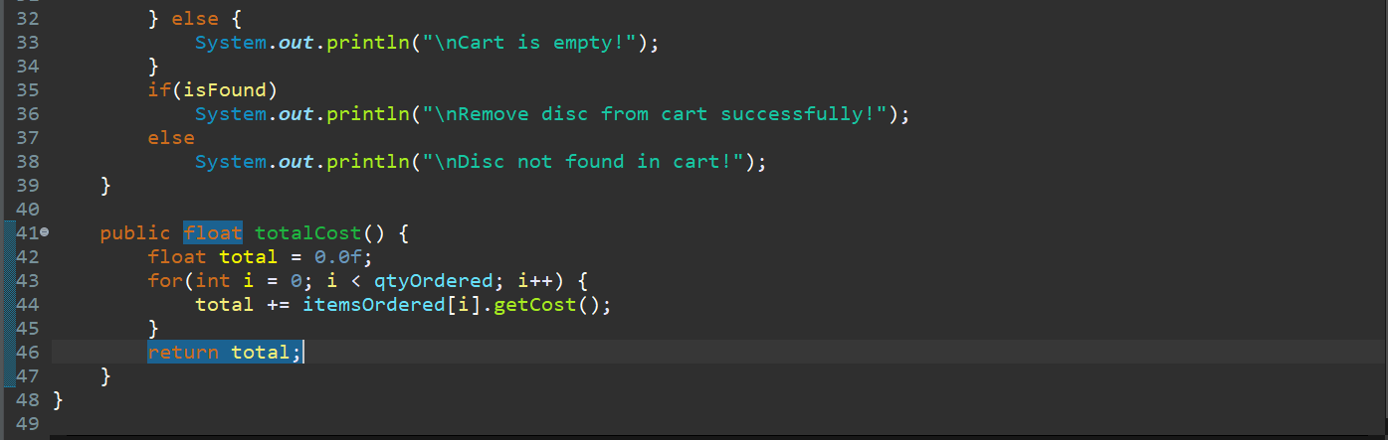

# Create Carts of DigitalVideoDiscs:

